QUESTION 26
Write pseudocode for a real-time data acquisition system using timers, semaphores, ISR, and queues.
ANSWER
1. PROBLEM UNDERSTANDING
A real-time data acquisition system must collect sensor samples at a fixed interval, respond to a hardware interrupt, synchronize the acquisition operation, and pass completed samples safely to another task for processing.
2. RTOS MECHANISM USED
A periodic timer establishes the sampling schedule. A binary semaphore releases the acquisition task at the required interval. An ISR handles the hardware data-ready event with short interrupt work. A queue transfers completed samples from acquisition to processing without direct task coupling.
3. STRUCTURED PSEUDOCODE
GLOBAL DEFINITIONS
• QUEUE SampleQueue WITH SIZE 16
• BINARY SEMAPHORE SampleReady
• PERIODIC TIMER SampleTimer = 10 ms
• STRUCT Sample { sensor_id, value, timestamp }
BEGIN
CREATE SampleQueue WITH SIZE 16
CREATE BINARY SEMAPHORE SampleReady
CREATE TASK AcquisitionTask WITH PRIORITY 3
CREATE TASK ProcessingTask WITH PRIORITY 2
CREATE TIMER SampleTimer PERIODIC EVERY 10 ms
START SampleTimer
START SCHEDULER
END
TIMER CALLBACK SampleTimerCallback
BEGIN
GIVE SampleReady
END
ISR ADC_DATA_READY_ISR
BEGIN
ACKNOWLEDGE ADC INTERRUPT
SIGNAL ADC_SAMPLE_COMPLETE
END
TASK AcquisitionTask
BEGIN
WHILE TRUE
WAIT SampleReady
START ADC CONVERSION
WAIT UNTIL ADC_SAMPLE_COMPLETE
READ ADC VALUE
CREATE sample WITH sensor_id, value, CURRENT_TIME
SEND sample TO SampleQueue
ENDWHILE
END
TASK ProcessingTask
BEGIN
WHILE TRUE
RECEIVE sample FROM SampleQueue
PROCESS sample
IF sample.value > LIMIT THEN
GENERATE ALERT
ENDIF
ENDWHILE
END

4. RTOS OPERATION SUMMARY
Mechanism | Performed by | Purpose
Periodic timer | SampleTimer | Creates the fixed 10 ms sampling schedule
Binary semaphore | AcquisitionTask / timer callback | Synchronizes acquisition with the sampling event
ISR | ADC_DATA_READY_ISR | Handles the hardware data-ready event quickly
Queue | AcquisitionTask → ProcessingTask | Buffers completed samples safely
Scheduler | RTOS kernel | Chooses the highest-priority READY task
LOGICAL FLOW DIAGRAM – Q26
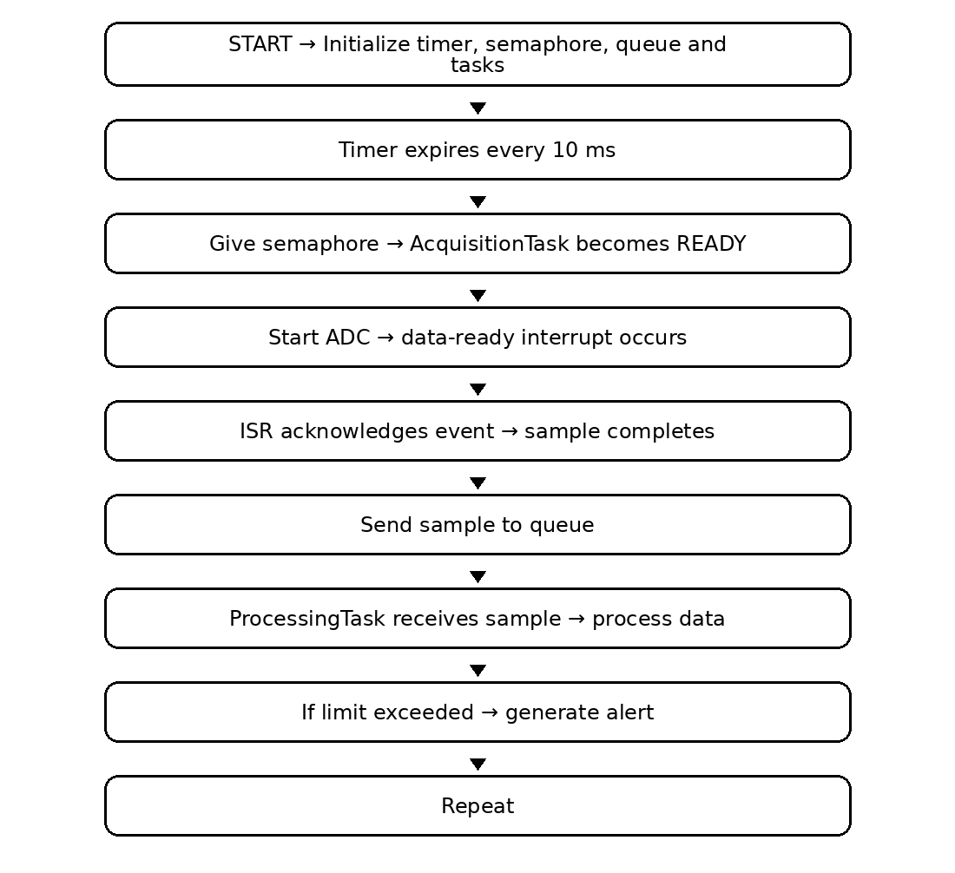
5. EXPLANATION
The timer controls when acquisition should occur. The semaphore prevents continuous polling and releases the acquisition task only at the sampling event. The ISR responds quickly to the ADC event and avoids lengthy processing inside interrupt context. The queue provides safe task-to-task communication so the processing task can consume samples independently.
KEY POINTS
• Fixed periodic sampling is provided by the timer.
• Semaphore provides synchronization.
• ISR performs only short interrupt work.
• Queue provides buffered inter-task communication.
• Processing is kept outside the ISR.
ASSUMPTIONS
• ADC conversion completes within the sampling period.
• Queue capacity is sufficient for expected bursts.
• Processing can keep up with the average sample rate.
• The RTOS supports timers, semaphores, queues, tasks and ISRs.
SUMMARY
The system uses a periodic timer to control sampling, a semaphore to synchronize the acquisition task, an ISR to handle the ADC data-ready event, and a queue to transfer completed samples safely to the processing task.
REAL-WORLD EXAMPLE
An industrial motor vibration-monitoring controller can use this design to sample an accelerometer every 10 ms, respond to the ADC data-ready interrupt, queue the timestamped vibration sample, and analyze it for abnormal vibration. If the measured level crosses a configured limit, the processing task can raise a maintenance alert.

QUESTION 27
Write pseudocode for round-robin scheduling with a 10ms time slice for 3 equal-priority tasks.
ANSWER
1. PROBLEM UNDERSTANDING
Three equal-priority tasks are continuously ready to execute. The scheduler must give each task a 10 ms CPU time slice and rotate among them so that one task does not monopolize the processor.
2. RTOS MECHANISM USED
Round-robin scheduling is used for tasks at the same priority. A scheduler tick measures the 10 ms quantum. When the quantum expires, the running task is moved to the end of the ready queue and the next READY task is selected.
3. STRUCTURED PSEUDOCODE
GLOBAL DEFINITIONS
• TIME_SLICE = 10 ms
• READY_QUEUE = [TaskA, TaskB, TaskC]
• TaskA, TaskB and TaskC have equal priority
• Scheduler tick tracks the remaining quantum
BEGIN
CREATE TaskA WITH PRIORITY 3
CREATE TaskB WITH PRIORITY 3
CREATE TaskC WITH PRIORITY 3
SET TIME_SLICE = 10 ms
ADD TaskA, TaskB, TaskC TO READY_QUEUE
START SCHEDULER
END
TIMER/SCHEDULER TICK
BEGIN
DECREMENT remaining_quantum
IF remaining_quantum = 0 THEN
SAVE CURRENT_TASK CONTEXT
MOVE CURRENT_TASK TO END OF READY_QUEUE
SELECT NEXT READY TASK
SET remaining_quantum = 10 ms
REQUEST CONTEXT_SWITCH
ENDIF
END
TASK TaskA
BEGIN
WHILE TRUE
EXECUTE WORK_A
ENDWHILE
END
TASK TaskB
BEGIN
WHILE TRUE
EXECUTE WORK_B
ENDWHILE
END
TASK TaskC
BEGIN
WHILE TRUE
EXECUTE WORK_C
ENDWHILE
END

4. RTOS OPERATION SUMMARY
Mechanism | Performed by | Purpose
Equal priority | TaskA, TaskB, TaskC | Places all three tasks in the same scheduling class
10 ms time slice | Scheduler tick | Limits one task's CPU turn
Ready queue | RTOS scheduler | Maintains cyclic order
Context switch | RTOS kernel | Changes the running task
Round-robin rotation | Scheduler | Moves the current task to the end of the queue
LOGICAL FLOW DIAGRAM – Q27
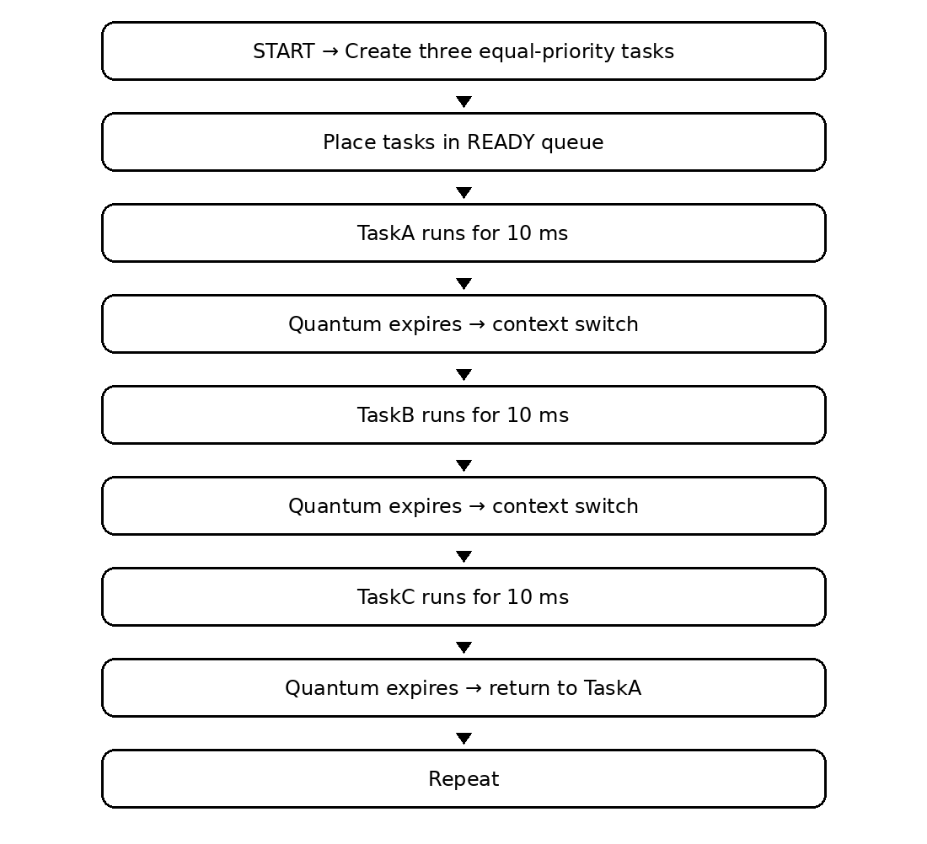
5. EXPLANATION
All three tasks have the same priority, so the scheduler uses the time slice to share CPU time fairly. After 10 ms, the current task's context is saved and that task is placed at the end of the READY queue. The next READY task runs for the next 10 ms. The cycle continues as long as the tasks remain READY.
KEY POINTS
• Equal-priority tasks share CPU time cyclically.
• The time slice is exactly 10 ms.
• Context switching occurs when the quantum expires.
• Blocked tasks are skipped until they become READY.
• Round-robin does not change the task priorities.
ASSUMPTIONS
• The scheduler tick is accurate enough for a 10 ms quantum.
• All three tasks are eligible to run continuously in this simplified case.
• No higher-priority task is considered in the example.
• Context-switch overhead is small compared with 10 ms.
SUMMARY
Round-robin scheduling gives the three equal-priority tasks a fair 10 ms CPU time slice. When a slice expires, the current task is moved to the end of the READY queue and the next equal-priority task runs.
REAL-WORLD EXAMPLE
An automated warehouse robot controller may use equal-priority housekeeping tasks for navigation-status updates, battery monitoring, and telemetry preparation. A 10 ms round-robin slice allows each housekeeping task to receive regular CPU time without permanently favoring one of them.

QUESTION 28
Write pseudocode for rate-monotonic scheduling (RMS) in a medical device with periodic and alarm tasks.
ANSWER
1. PROBLEM UNDERSTANDING
Periodic medical-monitoring tasks have known execution periods. The scheduler must assign fixed priorities according to their periods and allow an urgent alarm task to receive immediate service when a critical event occurs.
2. RTOS MECHANISM USED
Rate-monotonic scheduling assigns a higher fixed priority to a task with a shorter period. In this design, the ECG task has a shorter period than oxygen and temperature tasks, so it receives higher RMS priority. The alarm task is event-driven and is assigned the highest priority for urgent handling.
3. STRUCTURED PSEUDOCODE
GLOBAL DEFINITIONS
• ECG_PERIOD = 20 ms
• OXYGEN_PERIOD = 50 ms
• TEMPERATURE_PERIOD = 100 ms
• Priority: Alarm > ECG > Oxygen > Temperature
BEGIN
CREATE ECGTask WITH PERIOD 20 ms, PRIORITY 4
CREATE OxygenTask WITH PERIOD 50 ms, PRIORITY 3
CREATE TemperatureTask WITH PERIOD 100 ms, PRIORITY 2
CREATE AlarmTask WITH PRIORITY 5
START PERIODIC RELEASE TIMERS
START SCHEDULER
END
TASK ECGTask
BEGIN
WHILE TRUE
WAIT FOR NEXT 20 ms RELEASE
READ ECG
PROCESS ECG
ENDWHILE
END
TASK OxygenTask
BEGIN
WHILE TRUE
WAIT FOR NEXT 50 ms RELEASE
READ OXYGEN LEVEL
PROCESS OXYGEN
ENDWHILE
END
TASK TemperatureTask
BEGIN
WHILE TRUE
WAIT FOR NEXT 100 ms RELEASE
READ TEMPERATURE
PROCESS TEMPERATURE
ENDWHILE
END
ISR AlarmSensorISR
BEGIN
ACKNOWLEDGE ALARM INTERRUPT
SIGNAL AlarmEvent
END
TASK AlarmTask
BEGIN
WHILE TRUE
WAIT AlarmEvent
SOUND AUDIBLE ALARM
DISPLAY EMERGENCY WARNING
ENDWHILE
END

4. RTOS OPERATION SUMMARY
Mechanism | Performed by | Purpose
RMS fixed priority | RTOS scheduler | Shorter period receives higher fixed priority
Periodic release timers | ECG/Oxygen/Temperature tasks | Release tasks at their specified periods
Alarm ISR | AlarmSensorISR | Detects urgent hardware event
Alarm event | AlarmEvent | Wakes the alarm task
Preemption | RTOS kernel | Allows the highest-priority READY task to run
LOGICAL FLOW DIAGRAM – Q28
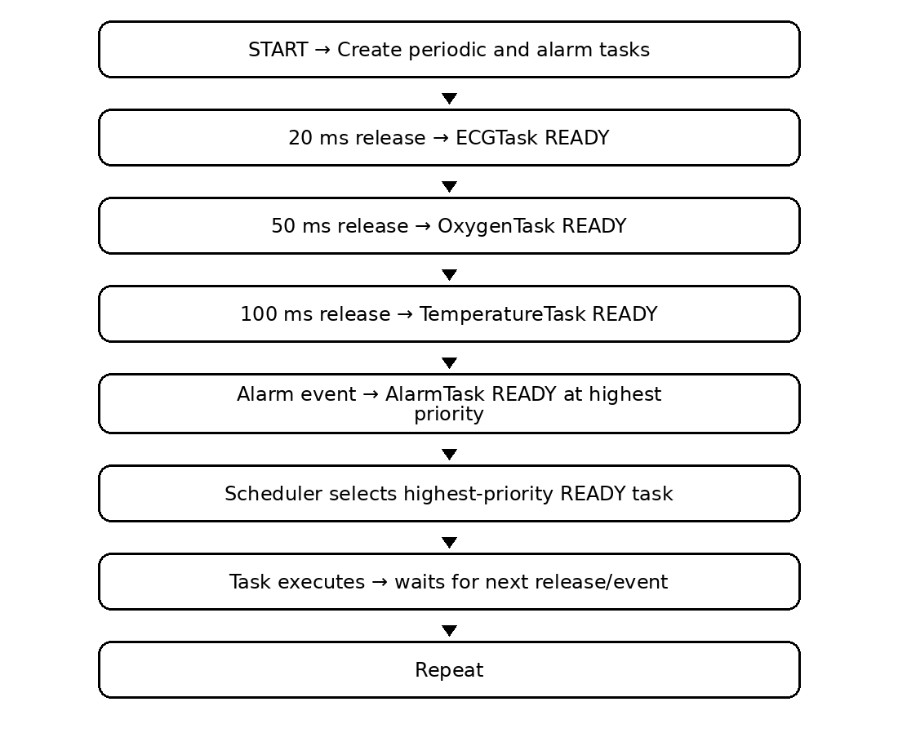
5. EXPLANATION
RMS keeps priorities fixed and derives them from task periods: the shorter the period, the higher the priority. Thus the 20 ms ECG task has higher RMS priority than the 50 ms oxygen task, which has higher priority than the 100 ms temperature task. The alarm task is event-driven and is given the highest priority in this design so a critical event can be handled immediately.
KEY POINTS
• RMS uses fixed priorities.
• Shorter period means higher RMS priority.
• Periodic tasks are released at known intervals.
• The alarm task is event-driven.
• The scheduler can preempt lower-priority work when a higher-priority task becomes READY.
ASSUMPTIONS
• The periodic task set is feasible for the processor.
• Execution times are short enough to meet deadlines.
• Alarm handling is intentionally assigned the highest priority.
• The RTOS supports fixed-priority preemptive scheduling.
SUMMARY
RMS assigns fixed priorities according to task periods: shorter-period periodic tasks receive higher priority. The alarm task is given the highest priority so an urgent event can be handled immediately.
REAL-WORLD EXAMPLE
A patient-monitoring device in an ICU can use this scheduling approach for ECG sampling, oxygen monitoring, and temperature monitoring. If a dangerous patient condition triggers an alarm sensor, the alarm task is released at the highest priority so the device can immediately activate an audible warning and emergency display.

QUESTION 29
Write pseudocode for a home automation system showing READY, RUNNING, BLOCKED, and SUSPENDED states for tasks.
ANSWER
1. PROBLEM UNDERSTANDING
The system must demonstrate the four task states. A task waits in READY until selected by the scheduler, becomes RUNNING when it executes, becomes BLOCKED while waiting for an event, and becomes SUSPENDED when the controller explicitly pauses it.
2. RTOS MECHANISM USED
Task-state management is demonstrated using scheduler selection, event-based blocking, and explicit suspension/resumption. The state is changed according to the event that occurs and the scheduler's decision.
3. STRUCTURED PSEUDOCODE
GLOBAL DEFINITIONS
• STATES = READY, RUNNING, BLOCKED, SUSPENDED
• Events: LightCommand, TemperatureUpdate, DoorAlert
• Tasks: LightingTask, ClimateTask, SecurityTask
BEGIN
CREATE LightingTask WITH PRIORITY 3
CREATE ClimateTask WITH PRIORITY 2
CREATE SecurityTask WITH PRIORITY 4
SET ALL TASKS TO READY
START SCHEDULER
END
TASK LightingTask
BEGIN
WHILE TRUE
WAIT LightCommand
STATE = BLOCKED
WHEN LightCommand ARRIVES:
STATE = READY
CONTROL LIGHTS
ENDWHILE
END
TASK ClimateTask
BEGIN
WHILE TRUE
WAIT TemperatureUpdate
STATE = BLOCKED
WHEN TemperatureUpdate ARRIVES:
STATE = READY
CONTROL HVAC
ENDWHILE
END
TASK SecurityTask
BEGIN
WHILE TRUE
WAIT DoorAlert
STATE = BLOCKED
WHEN DoorAlert ARRIVES:
STATE = READY
PROCESS SECURITY EVENT
ENDWHILE
END
CONTROLLER
BEGIN
IF maintenance_mode = TRUE THEN
SUSPEND LightingTask
SUSPEND ClimateTask
ELSE
RESUME LightingTask
RESUME ClimateTask
ENDIF
END
SCHEDULER
BEGIN
SELECT highest-priority READY task
SET selected task = RUNNING
EXECUTE selected task
IF task waits for event THEN
SET task = BLOCKED
ELSE IF task is suspended THEN
SET task = SUSPENDED
ELSE
SET task = READY
ENDIF
END

4. RTOS OPERATION SUMMARY
Mechanism | Performed by | Purpose
READY | RTOS scheduler | Task is eligible to run
RUNNING | RTOS scheduler | Selected task is executing
BLOCKED | Task/event mechanism | Task waits for an event or resource
SUSPENDED | Controller | Task is explicitly paused
RESUME | Controller/RTOS | Suspended task becomes eligible again
LOGICAL FLOW DIAGRAM – Q29
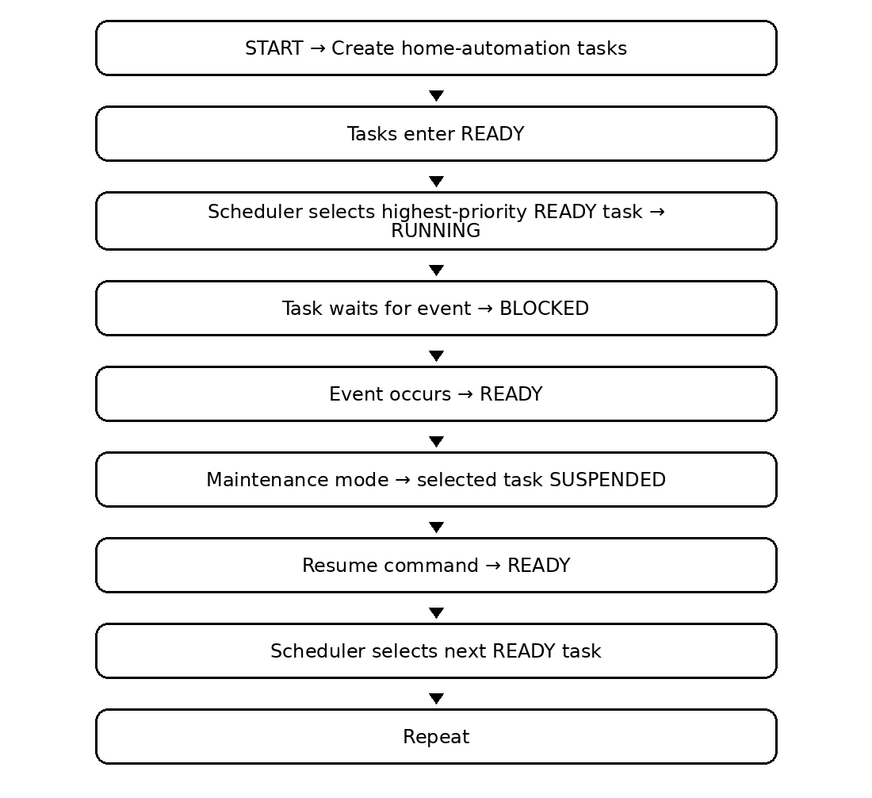
5. EXPLANATION
The scheduler selects a READY task and changes it to RUNNING. When the task waits for an event, it becomes BLOCKED and is not selected until that event occurs. An explicit maintenance command can move a task to SUSPENDED. When the task is resumed, it becomes eligible to run again and returns to READY.
KEY POINTS
• READY means eligible for CPU selection.
• RUNNING means currently executing.
• BLOCKED means waiting for an event/resource.
• SUSPENDED means explicitly paused.
• State transitions have clear scheduler or event triggers.
ASSUMPTIONS
• Events are delivered reliably.
• Suspended tasks remain inactive until resumed.
• Task priorities are configured before scheduling.
• The RTOS supports the required task-state operations.
SUMMARY
The home-automation tasks demonstrate READY, RUNNING, BLOCKED, and SUSPENDED states. The scheduler selects READY tasks, events release BLOCKED tasks, and explicit suspend/resume commands control SUSPENDED tasks.
REAL-WORLD EXAMPLE
A smart apartment controller can use these states for lighting, HVAC, and security tasks. For example, the lighting task can remain BLOCKED while waiting for a user command, become READY when the command arrives, run when selected by the scheduler, and be SUSPENDED during maintenance.

QUESTION 30
Write pseudocode for a home automation system showing task state transitions and scheduler operation.
ANSWER
1. PROBLEM UNDERSTANDING
The system must show how task state transitions interact with scheduler operation. Tasks enter READY after creation or event release, move to RUNNING when selected, become BLOCKED while waiting for events, and may become SUSPENDED through an explicit controller command.
2. RTOS MECHANISM USED
A preemptive RTOS scheduler repeatedly selects the highest-priority READY task. Event mechanisms cause BLOCKED tasks to return to READY, while explicit suspend/resume operations move tasks between SUSPENDED and READY.
3. STRUCTURED PSEUDOCODE
GLOBAL DEFINITIONS
• STATES = READY, RUNNING, BLOCKED, SUSPENDED
• Events: OccupancyEvent, PowerUpdate, UserCommand
• READY_LIST stores tasks eligible to execute
BEGIN
CREATE OccupancyTask WITH PRIORITY 4
CREATE LightingTask WITH PRIORITY 3
CREATE EnergyTask WITH PRIORITY 2
CREATE ControllerTask WITH PRIORITY 5
ADD ACTIVE TASKS TO READY_LIST
START SCHEDULER
END
SCHEDULER
BEGIN
LOOP FOREVER
SELECT highest-priority task FROM READY_LIST
SET selected task = RUNNING
RUN selected task
IF task waits for event THEN
SET task = BLOCKED
ELSE IF task is suspended THEN
SET task = SUSPENDED
ELSE
SET task = READY
ADD task TO READY_LIST
ENDIF
ENDLOOP
END
TASK OccupancyTask
BEGIN
WHILE TRUE
WAIT OccupancyEvent
DETECT OCCUPANCY
IF person_detected THEN
SIGNAL UserCommand
ENDIF
ENDWHILE
END
TASK LightingTask
BEGIN
WHILE TRUE
WAIT UserCommand
CONTROL LIGHTING
ENDWHILE
END
TASK EnergyTask
BEGIN
WHILE TRUE
WAIT PowerUpdate
CALCULATE ENERGY USAGE
APPLY ENERGY-SAVING POLICY
ENDWHILE
END
TASK ControllerTask
BEGIN
IF service_mode = TRUE THEN
SUSPEND EnergyTask
ELSE
RESUME EnergyTask
ENDIF
END

4. RTOS OPERATION SUMMARY
Mechanism | Performed by | Purpose
Task creation | RTOS | Creates tasks and places active tasks in READY
Scheduler | RTOS kernel | Selects the highest-priority READY task
RUNNING | Scheduler | Represents the selected executing task
BLOCKED | Event mechanism | Task waits without using CPU
SUSPENDED | Controller | Task is explicitly stopped
READY | Event/resume | Task becomes eligible to run again
LOGICAL FLOW DIAGRAM – Q30
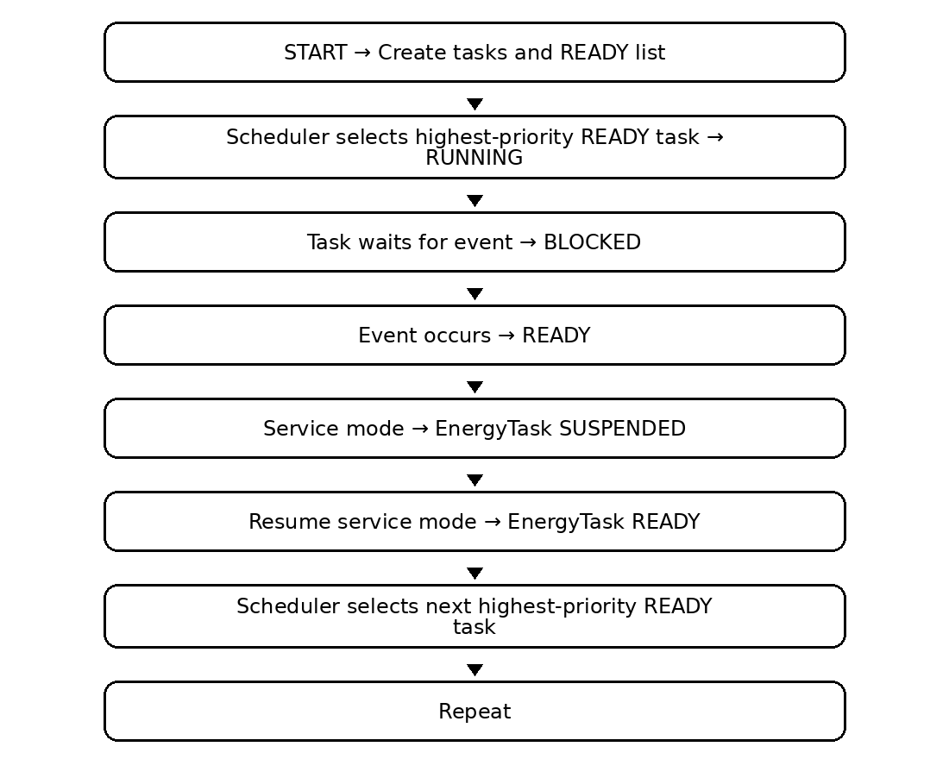
5. EXPLANATION
The scheduler and task-state transitions work together continuously. A READY task is selected and becomes RUNNING. If it waits for an event, it becomes BLOCKED and leaves the set of runnable tasks. An explicit service command can suspend a task, placing it in SUSPENDED until resume. When an event occurs or a suspended task is resumed, it returns to READY and can be selected again according to priority.
KEY POINTS
• The READY list contains runnable tasks.
• The scheduler selects the highest-priority READY task.
• BLOCKED tasks wait for events and do not consume CPU.
• SUSPENDED tasks require explicit resumption.
• Every state transition has a defined trigger.
ASSUMPTIONS
• The scheduler is preemptive priority-based.
• Events are reliably delivered.
• Suspension is controlled by the controller task.
• Task execution times are suitable for the home-automation response requirement.
SUMMARY
The scheduler repeatedly selects the highest-priority READY task and manages its transitions to RUNNING, BLOCKED, SUSPENDED, and back to READY according to events and controller commands.
REAL-WORLD EXAMPLE
A smart-home energy-management controller can use this design to coordinate occupancy detection, lighting control, and energy optimization. Occupancy events can wake the occupancy task, lighting can respond to user commands, and an energy task can be suspended during service mode and resumed afterward.

